**Course Purchase**

1. Website URL: [**https://movimientolatinouniversity.com/**](https://movimientolatinouniversity.com/)
2. In website home page “**Find the Right Online Course for you**”.

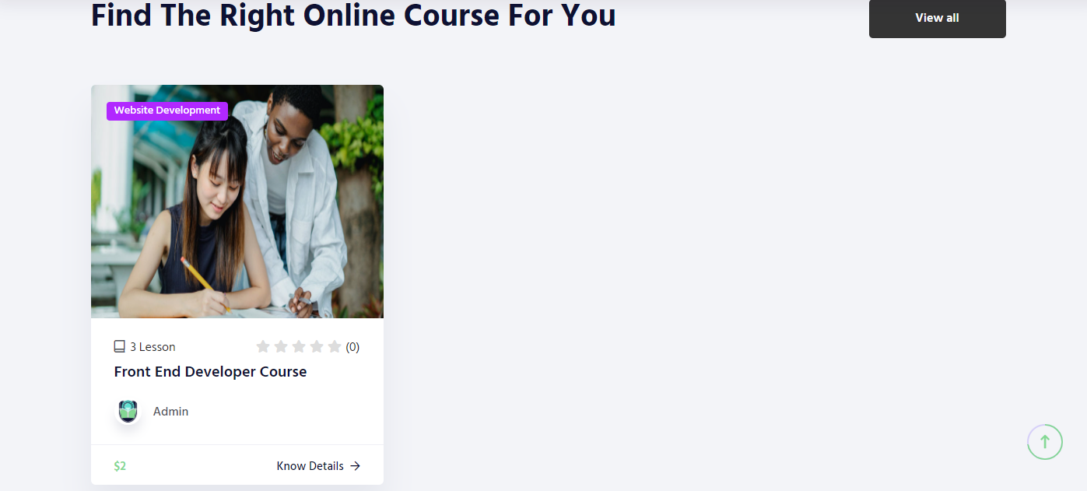

1. Click on “**Know Details**” button, it will redirect to the course details page.

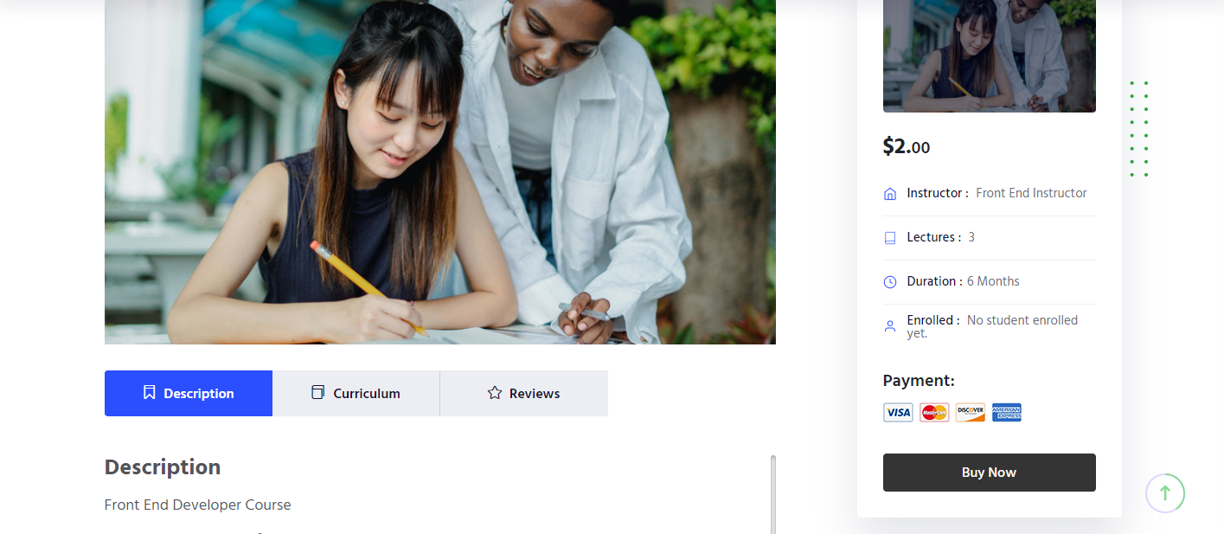

1. After click on the “Buy Now”, it will redirect to the stripe payment page.

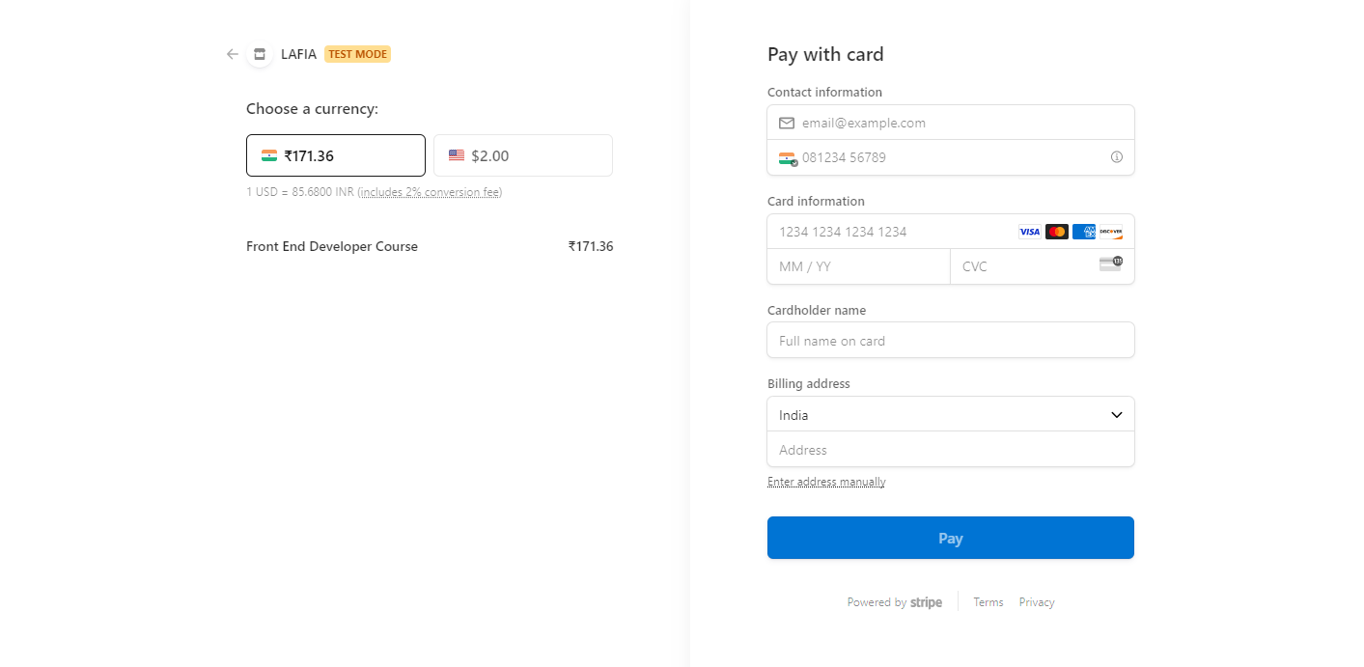

1. Once “**Pay**”, after fill all the mandatory details, new user will register.

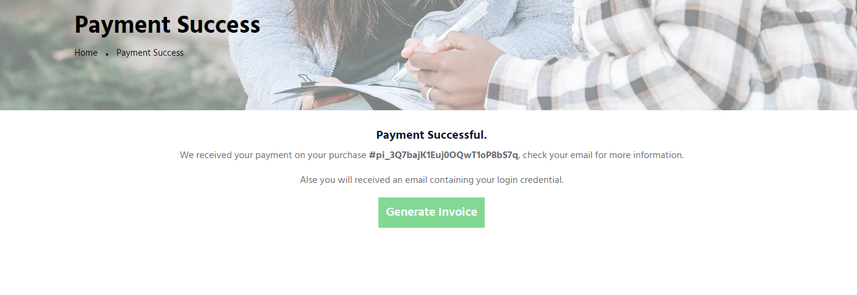

1. New user will be listed in the admin also.

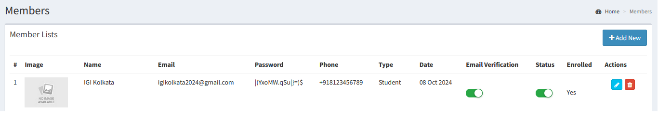

1. Once user try to login with the provided login credential, it will redirect to the reset password page.

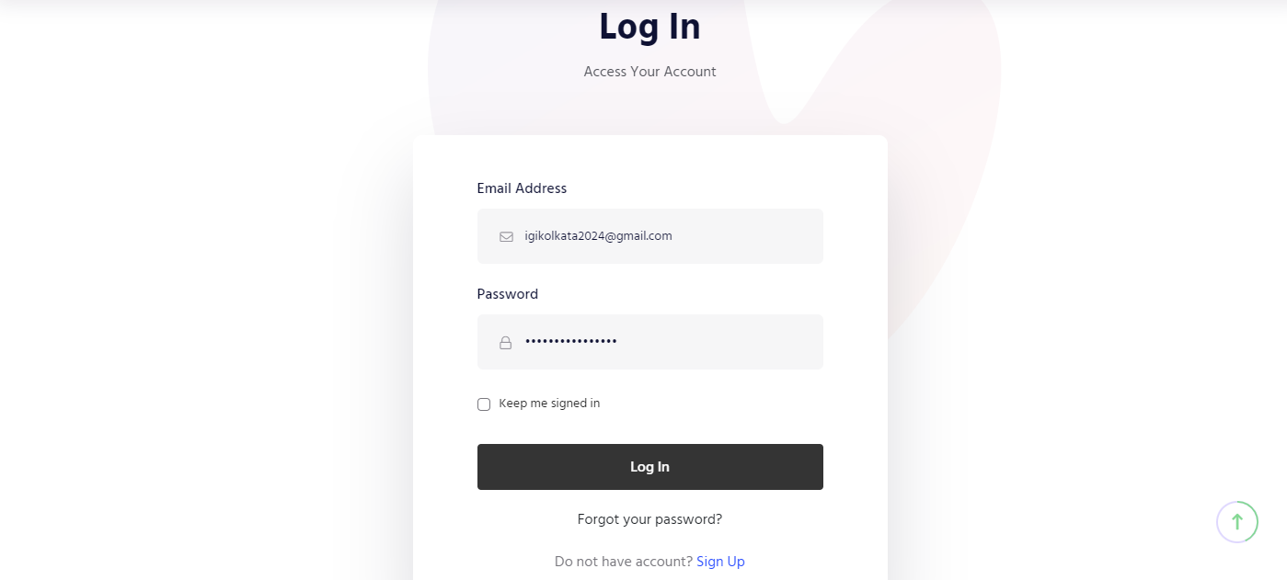

1. After a successful reset password, user will be able to login to their dashboard.

